# File permissions in Linux

## Project description

Manage Authorization in Linux

## Check file and directory details

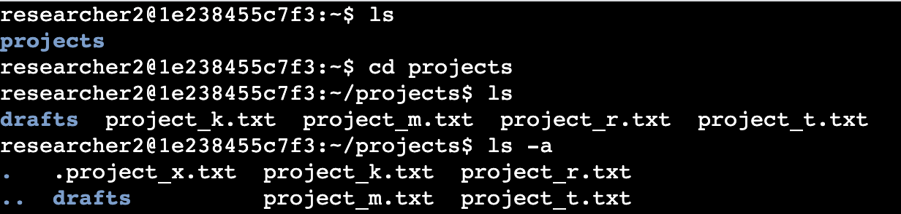

## Describe the permissions string

## Change file permissions

## Change file permissions on a hidden file

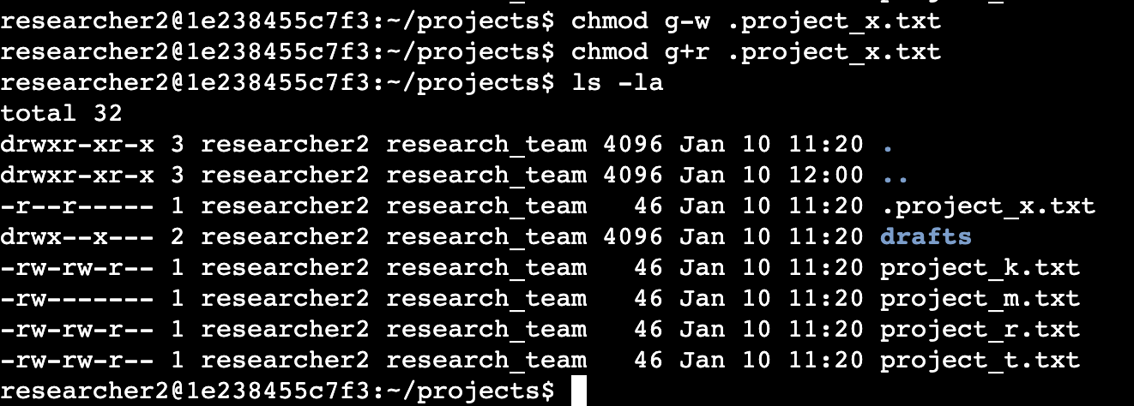

## Change directory permissions

## Summary

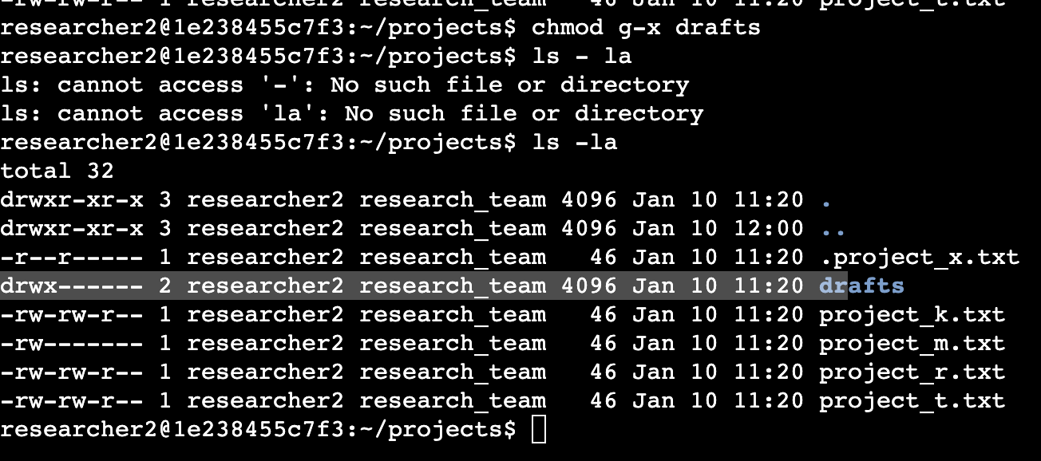

It was a great time working on the file and directory permission on Linux!

I have practical experience in using basic Linux Bash shell commands to

* examine file and directory permissions,
* change permissions on files, and
* change permissions on directories.

This is an important milestone on my journey toward managing authorisation in Linux!